Creating a Customer Folder
These are the steps needed to create a new customer folder that includes a Projects folder.
In File Explorer go to
C:\TFS\nnnnnnn\EmpowerNet\Main\Updates\Customers
and copy the Template folder to a new folder.
Rename the folder to the customer, for example Baker.
Delete the Bin and DebugBin subfolders. They’ll be automatically created as needed.
If the customer folder already exists with Reports and Scripts subfolders, but no Projects subfolder, then copy the Template Projects folder to the customer folder.
- Open the Projects folder and
  - Rename folder Empower.Customer to <customer>.Empower, for example, Baker.Empower.
  - Rename folder Empower.Windows.Customer to <customer>.Empower.Windows, for example, Baker.Empower.Windows.

- Open the <customer>.Empower folder and rename the three Visual Basic objects to <customer>.Empower. Leave the folder called Customer as Customer.
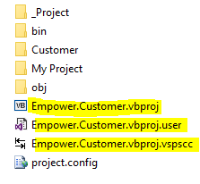
- Open the <customer>.Empower.Windows folder and rename the two Visual Basic objects to <customer>.Empower.Windows.
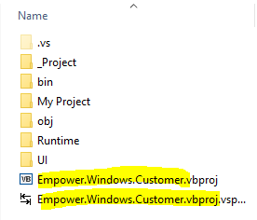
In Visual Studio’s Solution Explorer,
- Eight click on Customers and select Add > New Solution Folder. Name the folder <customer>, for example Baker.

- Right click on the new customer folder and select Add > Existing Project to add the <customer>.Empower project. It will be called <customer>.Empower.vbproj and will be in the folder
C:\TFS\nnnnnnn\EmpowerNet\Main\Updates\Customers\<customer>\Projects\<customer>.Empower
- Right click on the new customer folder and select Add > Existing Project to add the <customer>.Empower.Windows project.

- Open the <customer>.Empower project and rename the Customer folder to <customer>.

- Right click on the <customer.Empower project and select Properties.
Go to Applications and rename the Assembly Name to <customer>.Empower.
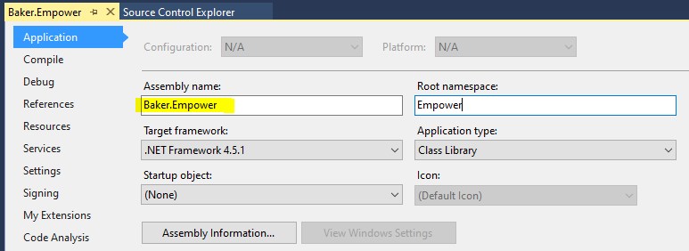
- Right click on the <customer>.Empower.Windows project and select Properties.
Go to Applications and rename the Assembly Name to <customer>.Empower>Windows and the Root Namespace to Empower.Windows.<customer>.
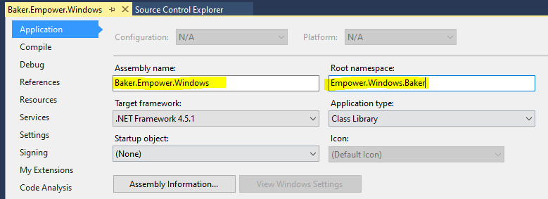
Go to References and add the <customer>.Empower project to the References.
Delete the Empower.Customer reference.
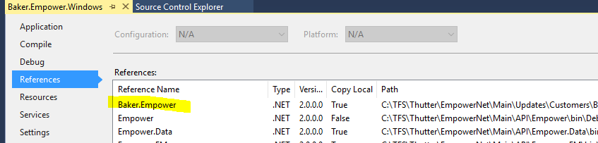

- Right click on the Windows Solution and select Properties.
Under Common Properties, select Project Dependencies.
Change the Project to EmpowerWin.
Check the checkboxes for the two new projects so that they are built when you click the Start button to run EmpowerWin from Visual Studio. This also causes them to be built (i.e., the dll’s to be created) when you do a release.
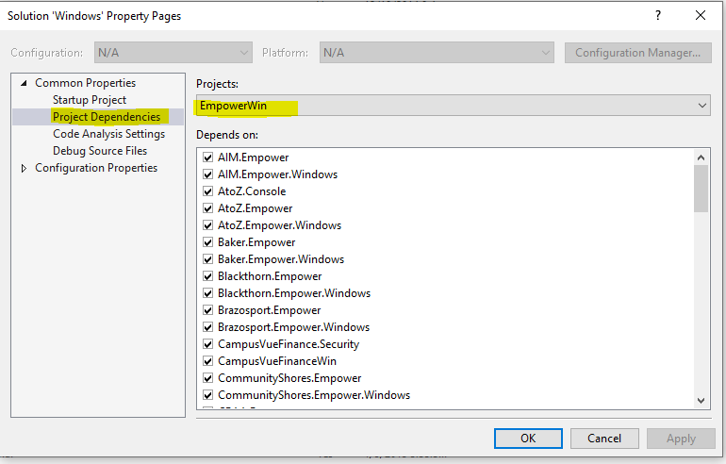

In File Explorer, you can delete the Empower.Customer objects from the \bin\Debug and \bin\Release folders in both the customer and customer windows projects folders. Those files were created when the \Template\Projects folder was copied.
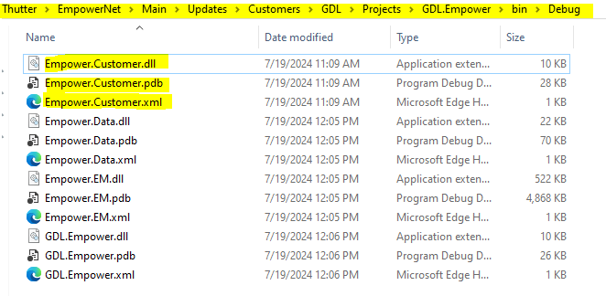
In Visual Studio’s Source Control Explorer, (I’m not sure about this step)
- Navigate to $/EmpowerNet/Main/Updates/Customers.

- Right click on <customers> and select Add Items to Folder.

- Add the new customer folder. When you click Next, Visual Studio will show you that it is going to add some items to Source Control and exclude some items. Start with the assumption that this is what you want to add. When creating Baker’s projects, I ended up adding things piece meal which was probably wrong.
ReleaseBuild
Open the ReleaseBuild solution.
Under the Customers folder, right click and Add a “New Solution Folder” called <customer>.
Right click on the <customer> folder and Add an “Existing Project”. Add the <customer>.Empower project.
Right click on the <customer> folder and Add an “Existing Project”. Add the <customer>.Empower.Windows project.
If the projects aren’t added to the ReleaseBuild solution, they don’t get built and moved up to the FTP site as when we execute EmpowerRelease.

